Open Stargate quote
Double click Serial Number field:
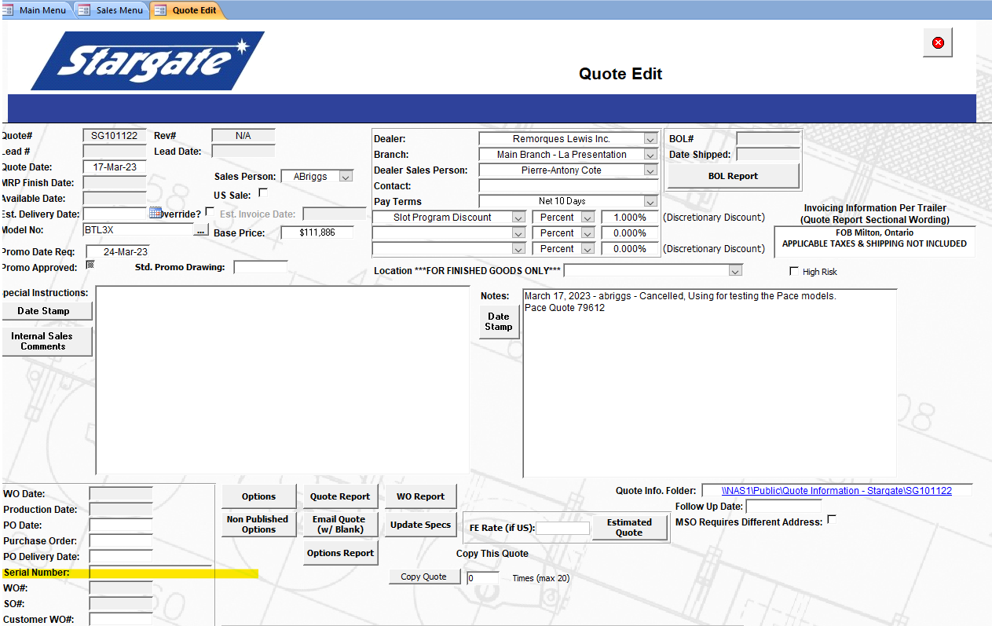

Here select either show breakdown or no: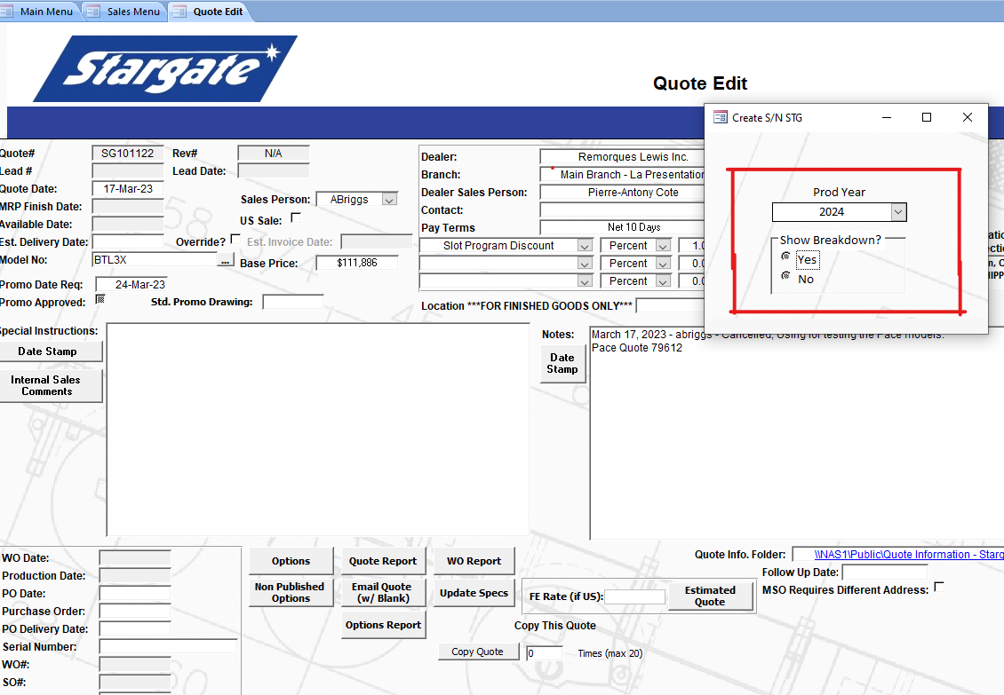
Hiding Breakdown
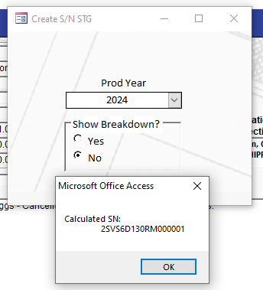

Showing Breakdown: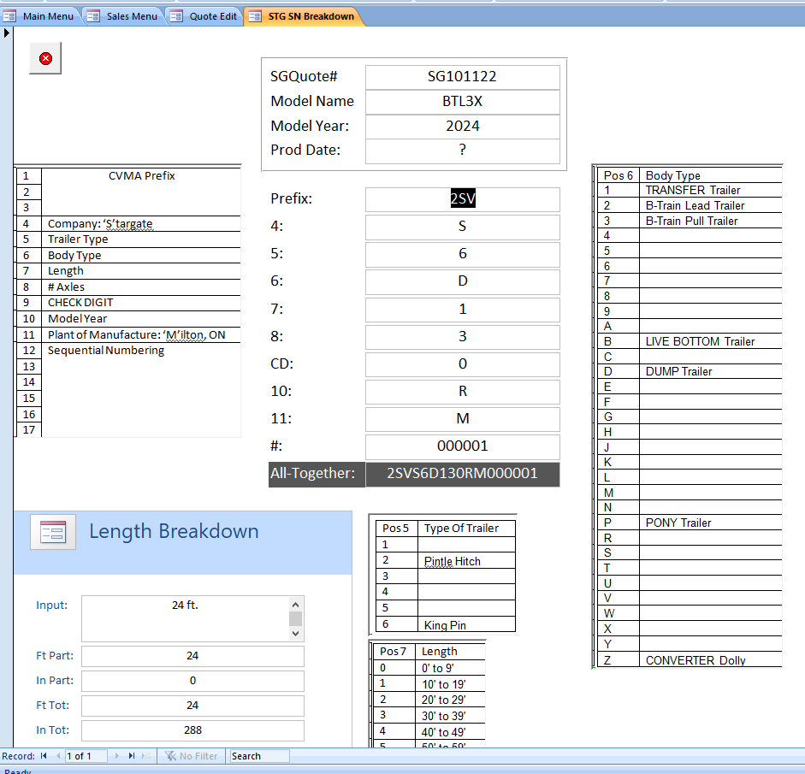

After reviewing close the pop-up or form.
Now you will be shown this:
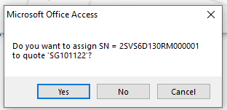

Click yes to assign this serial, or no to go back to the quote screen, having made no changes.

